ZenLodges – Hotel Booking System
Deliverable 2 – Part C: Project Document
Team: XCoders | Due: March 25, 2026 | Course: Software Engineering
Submitted To: Mam Labiba Fahad

1. Introduction
ZenLodges is a desktop hotel booking system developed using Java and JavaFX. It includes everything from user sign-up to hotel browsing to booking and managing hotel rooms.
Sprint 1:The team developed the basic system for booking hotel rooms. This included developing the sign-up system for users, browsing hotels, booking hotel rooms, and managing hotel rooms.
Sprint 2:The team developed the home page for the hotel booking system and implemented the feature for multiple hotels instead of just one hotel.
Sprint 3:The team developed the feature for searching hotels, viewing hotel rooms, booking hotel rooms, and so on.
Sprint 4:The team developed the complete hotel booking system with booking management for users and admin, along with rules for maintaining consistency in the system.
Thus, the hotel booking system developed by the team is complete and fully usable, where users can sign up for the system, hotel administrators can manage their hotels, users can book hotel rooms, administrators can manage their bookings, and users can manage their bookings just like a real hotel booking system.

2. Project Vision
ZenLodges is a simple and reliable hotel booking system, where the admin can handle the hotel, and the user can easily book a room by searching.
ZenLodges uses three different roles: Platform Admin, Hotel Admin, and User, with different features for each.
After Sprint 1, the system was enhanced to accommodate multiple hotels and a better booking process.
The aim is to maintain a simple system while dealing with real-life situations, for example, booking conflicts and cancellations.

3. Intended Use of the System

3.1 Who Will Use the System
Platform Admin: Manages the entire platform. Reviews and approves or rejects hotel registration requests. Can see all bookings and users across the system.
Hotel Admin: Registers their hotel on the platform and waits for approval. Once approved, they can add rooms, view bookings, and manage their hotel details.
Regular User (Guest/Customer): Creates an account, searches for hotels, views available rooms, books a room, and manages their bookings from their dashboard.

3.2 How They Will Use It
- Platform Admin logs in and approves or rejects hotel registrations.
- Hotel Admin registers, adds a hotel, and can perform other hotel-related tasks after approval.
- Users register, can search for hotels, view rooms, and book hotels.
- Both users and admins can view and cancel bookings.

3.3 Stakeholder Updates from Sprint 2
- During Sprint 2, we learned that hotel admins couldn’t manage their hotels.
- This was addressed by creating a Hotel Admin role with its own signup page and dashboard.
- The Platform Admin role was also updated to reflect just approvals and control.

4. Features and Functionality

4.1 Features Completed in Sprint 1
- Sprint 1 established the fundamental base for ZenLodges by providing multi-level login for Platform Admin, Hotel Admin, and User.
- Redirects users to their respective dashboards depending on their user roles.
- Admin can add rooms with their details and view them in a table format.
- A basic database with Users and Rooms tables was also established.

4.2 New Features Implemented in Sprint 2,3,4

Sprint 2 – Home Page & Multi-Hotel Foundation
- Sprint 2 introduced a home page with a navigation bar, a hero section, and call-to-action buttons.
- The navigation bar displays "Login/Logout" depending on the user session.
- The database was updated to include multiple hotels, a "Hotels" table, and a relationship between "Hotels" and "Rooms."
- Hotel Admins can register hotels, and duplicate checking was added. The Platform Admin Dashboard allows admins to accept or reject requests.

Sprint 3 – Search, Rooms, and Booking
- Sprint 3 included hotel search based on location and type, with the result displayed in a scrollable list.
- Users may view hotel information with room information and availability.
- A dialog for booking a hotel allows users to select dates with checks for double booking.
- A confirmation dialog is displayed for a successful booking.

Sprint 4 – Booking Management
- Sprint 4 introduced user and hotel admin booking management features.
- User booking management features include viewing and cancelling upcoming bookings, which are recorded as CANCELLED.
- Hotel admin features include booking filtering by date or user and cancellation of confirmed bookings.
- The Book button is disabled when a room is unavailable, and performance indexes were introduced.

4.3 How Sprint 2 Improved System Capability
- Sprint 1: Login and room list were added.
- Sprint 2 , 3, 4: The system is now fully functional. Users can search and book hotels. Admins can manage hotels and bookings.
- The system behaves like a real-world system due to business rules like date conflicts and user roles.

5. User Stories
The following user stories were implemented in Sprint 2. Sub-tasks and detailed backlog breakdowns are provided in Part B (Section 2).
US-4: Home Page Navigation
Sprint: 2.1
As a visitor, I want to see a home page with navigation so I can access login, search, and contact.
Acceptance Criteria: The navigation bar is visible at all times. All buttons redirect to the correct screens. The nav bar toggles between Login and Logout depending on the session state.
US-5: Multi-Hotel Support
Sprint: 2.1
As an admin, I want the system to support multiple hotels with types and locations.
Acceptance Criteria: The hotel registration form works correctly. Duplicate hotel names in the same location are blocked. Registered hotels appear in the admin table.
US-6: Platform Admin Approval
Sprint: 2.1
As a platform admin, I want to approve or reject hotel listings.
Acceptance Criteria: Pending hotels are visible in the dashboard. Approving or rejecting a hotel updates its status correctly. Cascading database rules work as expected.
US-7: Hotel Search
Sprint: 2.2
As a user, I want to search hotels by location and type.
Acceptance Criteria: Search returns filtered results based on location and type. Clicking a hotel from the results list opens the Hotel Details screen.
US-8: Room Browsing
Sprint: 2.2
As a user, I want to view rooms for a selected hotel.
Acceptance Criteria: Rooms for the selected hotel are displayed in a table. Unavailable rooms have the Book button disabled.
US-9: Room Booking
Sprint: 2.2
As a user, I want to book a room with check-in and check-out dates.
Acceptance Criteria: The date conflict check works correctly. The booking is saved to the database. A confirmation message is shown to the user after successful booking.
US-10: User Booking Management
Sprint: 2.3
As a user, I want to view my bookings and cancel if needed.
Acceptance Criteria: The booking list is displayed correctly. Users can cancel bookings only for future check-in dates.
US-11: Admin Booking Management
Sprint: 2.3
As a hotel admin, I want to view and cancel bookings for my hotel.
Acceptance Criteria: Hotel bookings are visible with working filters. The admin cancel override functions correctly.
US-12: Double Booking Prevention
Sprint: 2.3
As the system, I want to prevent double booking and show accurate availability.
Acceptance Criteria: Overlap validation blocks any duplicate date bookings. Only rooms with available status are shown for booking.

6. Non-Functional Requirements (NFR)
Non-functional requirements were defined in Sprints, focusing on performance, usability, reliability, security, and scalability.

Performance
The system must display hotel search results and room lists within 2 seconds, and confirm bookings within 3 seconds.

Usability
Users can complete bookings within 5 minutes, with clear error messages for any invalid input.

Reliability
The system must run without crashing for 2 hours and prevent conflicting bookings.

Security
Users can only access features for their role, and sessions are invalidated on logout to block unauthorized access.

Scalability
The system must support adding hotels and rooms without code changes, with database indexes to keep queries fast.

7. Sprint 2 Implementation Screenshots
The following section describes the key screens implemented during Sprint 2. Screenshots from the running application are included to demonstrate the functionality of each module.

Sprint 2 – Home Page & Multi-Hotel Structure
Screenshot 1: Home Page
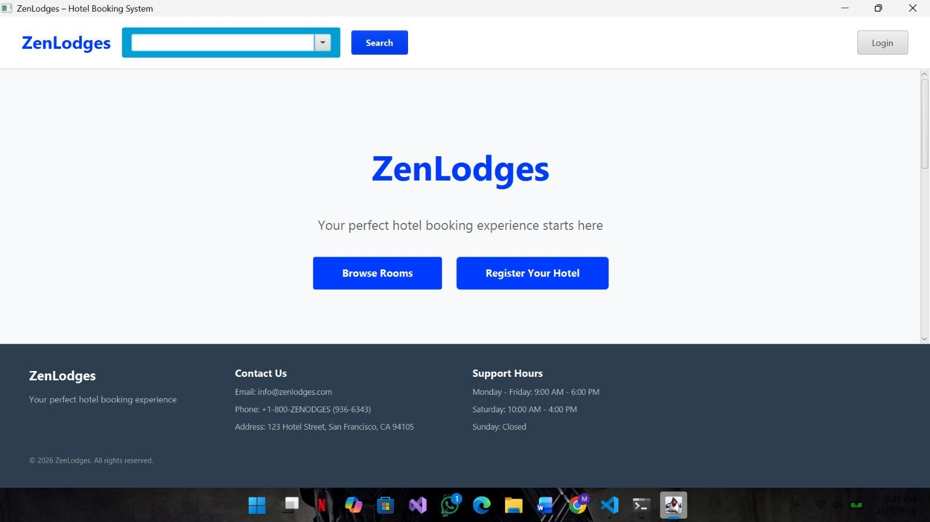
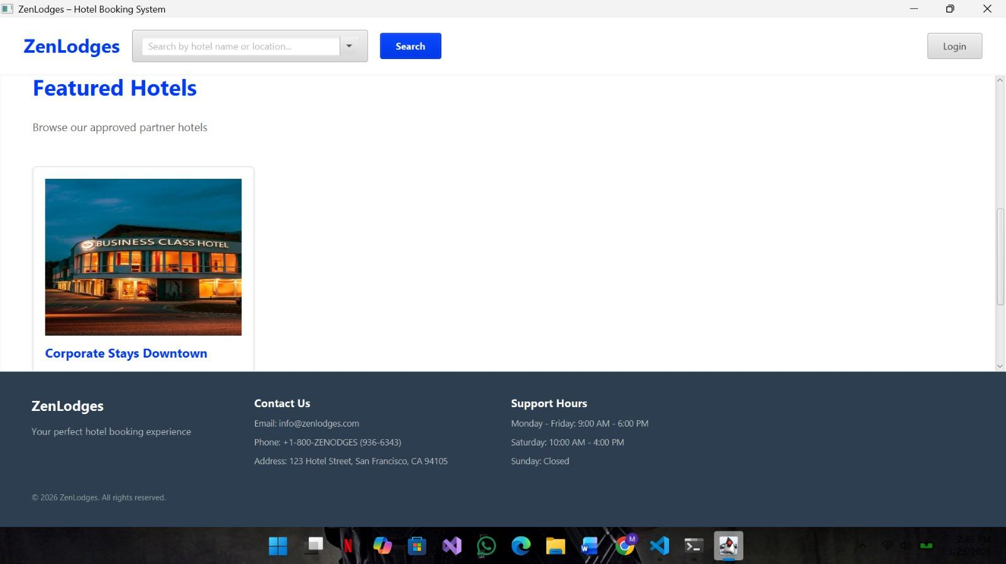
Screenshot 2: Hotel Registration Form
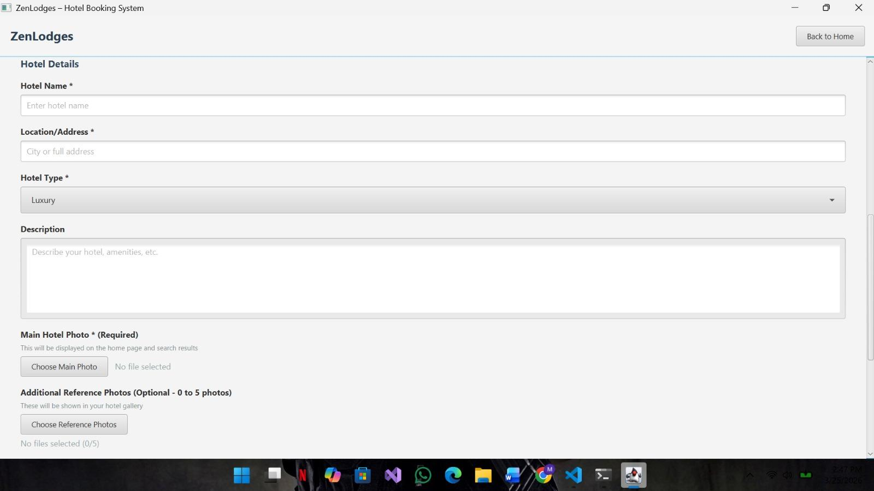
Screenshot 3: Platform Admin Dashboard
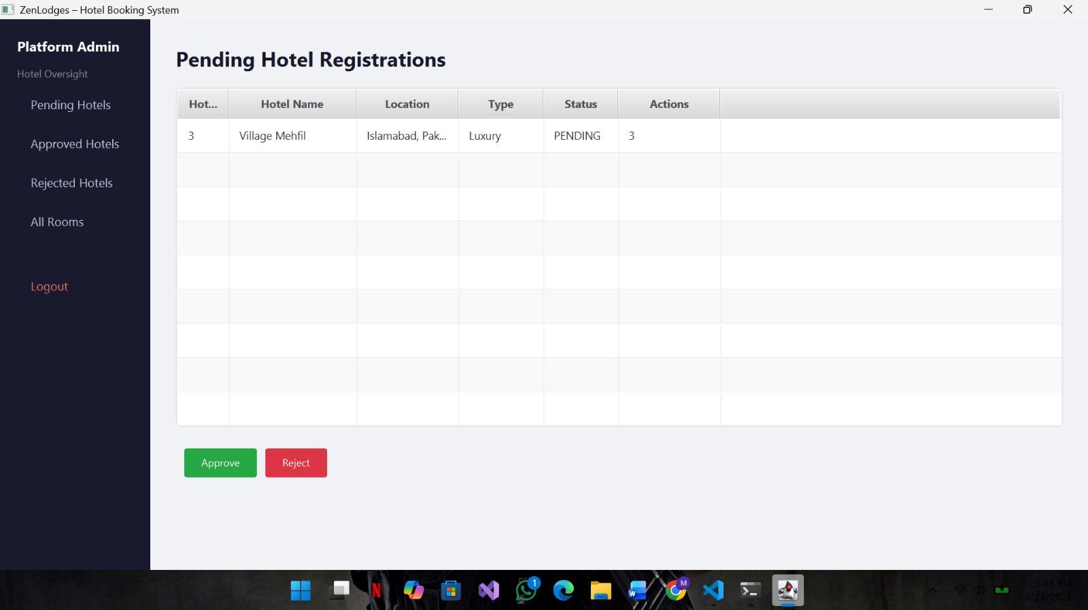

Sprint 3 – Search, Rooms, and Booking
Screenshot 4: Hotel Details / Room List
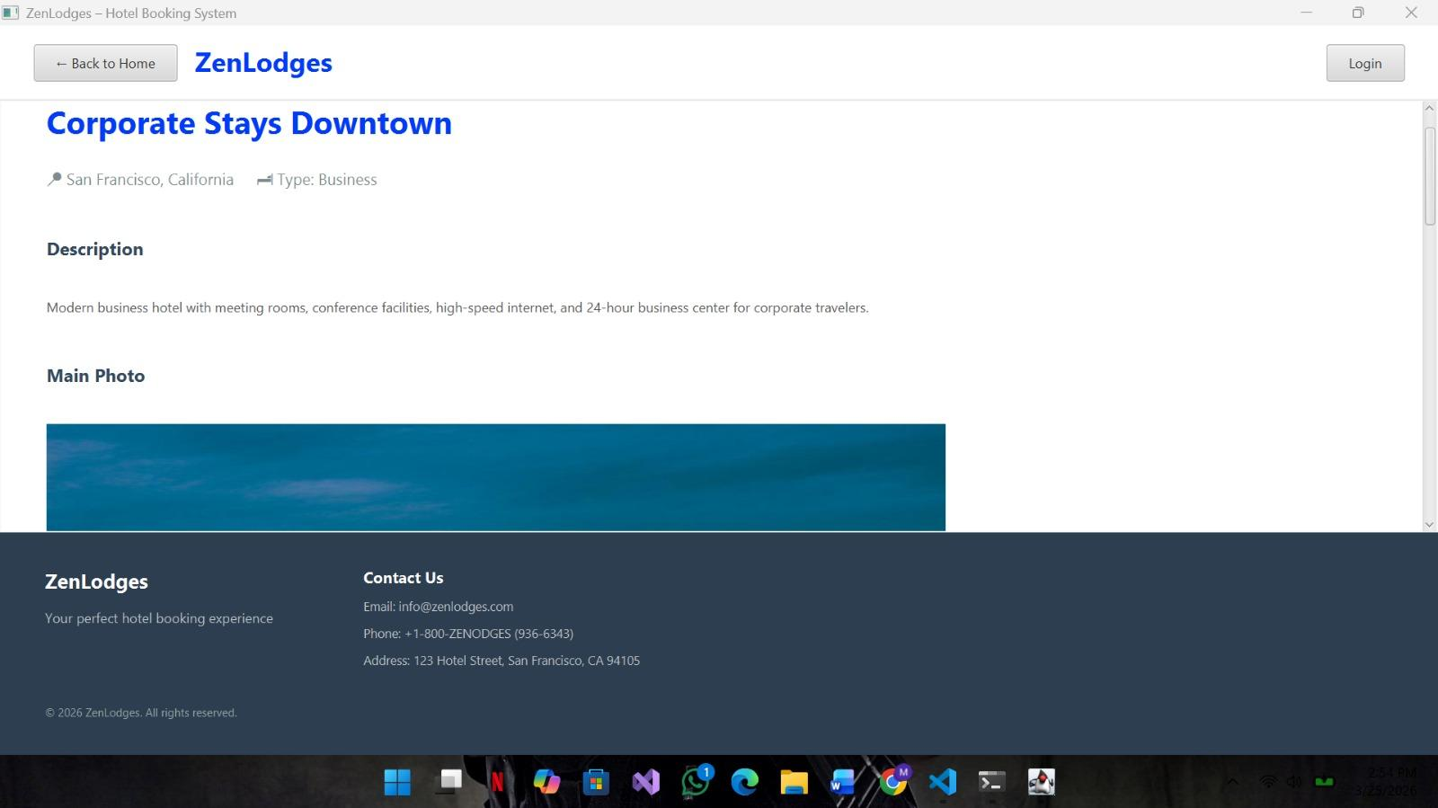
Screenshot 5: Booking Dialog
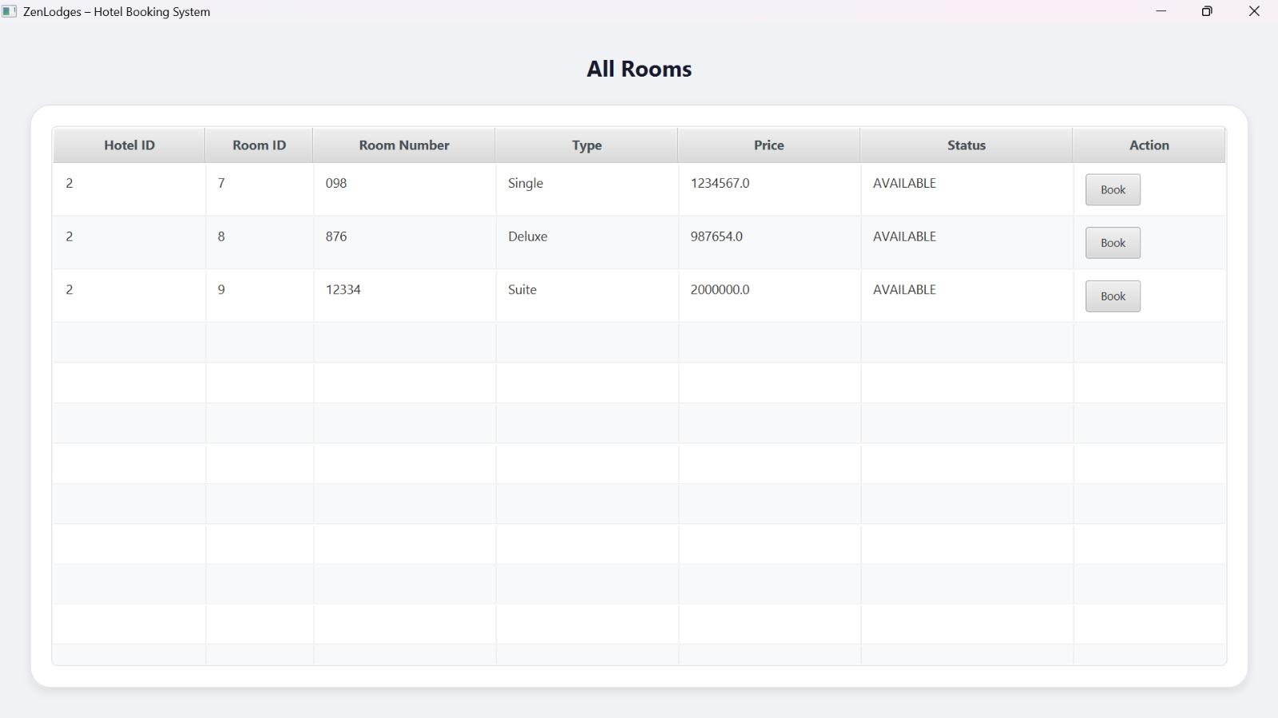

Sprint 4 – Booking Management
Screenshot 6: User Booking Dashboard
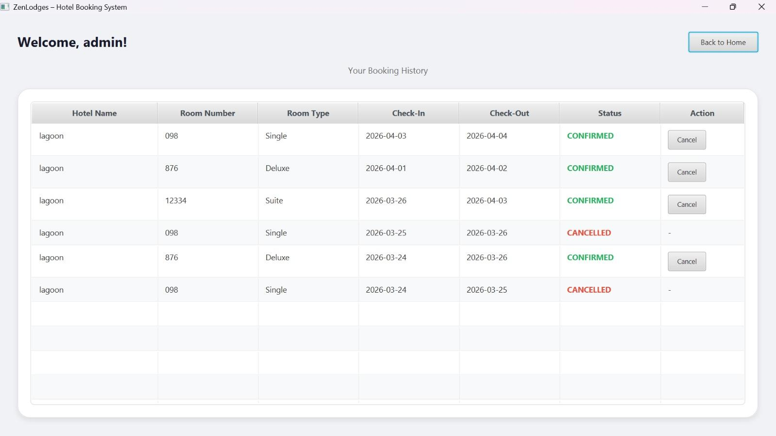
Screenshot 7: Admin Booking Management
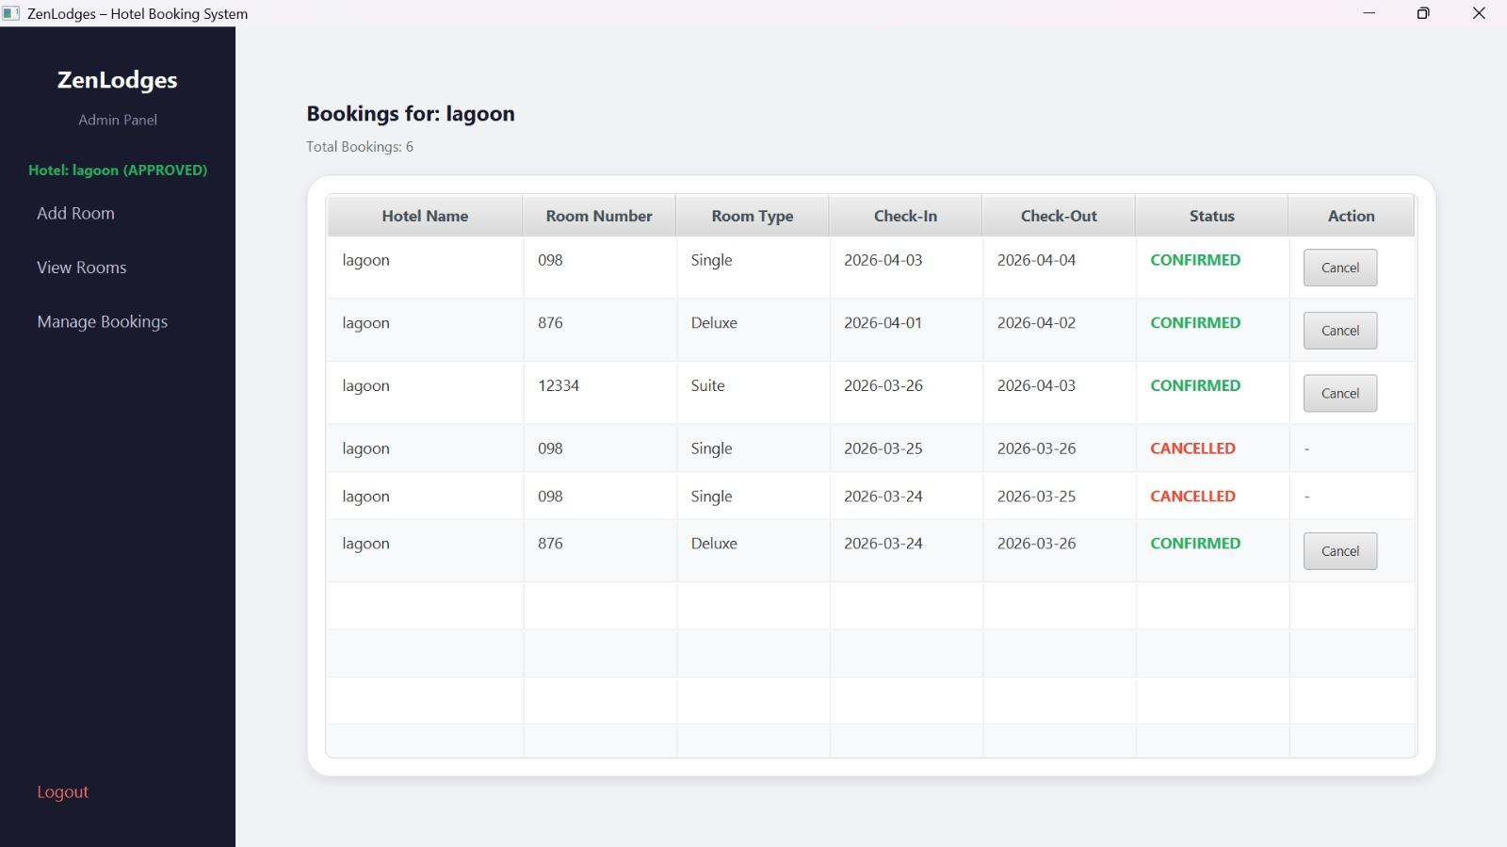

8. Work Division for Sprint 2,3,4
Tasks for Sprint 2 were divided during sprint planning based on each member's role and expertise. The division was discussed in the team WhatsApp group and confirmed at the first sprint meeting.
Member 1: Ahmed Ijaz (Team Lead / Scrum Master)
Role: Backend Dev, Frontend Dev – Sprint 3 Lead
Tasks Completed:
- Hotel search by location and type
- Hotel Details screen with room TableView
- RoomService: getRoomsByHotel(), checkAvailability()
- Booking creation with date conflict check
- BookingService.bookRoom() implementation
- DB room-hotel FK relationship setup
Member 2: Shayan Asad (Product Owner)
Role: Backend Dev, Frontend Dev – Sprint 2 Lead
Tasks Completed:
- Home Page UI (BorderPane, NavBar, Hero section)
- Session-aware Login/Logout toggle
- Hotel model and Hotels table schema
- HotelService: registerHotel(), getApprovedHotels()
- Hotel registration form with duplicate validation
- Platform Admin approval/rejection dashboard
Member 3: Sardar Muneeb-ur-Rehman (UI Designer / Tester)
Role: Backend Dev, Frontend Dev – Sprint 4 Lead
Tasks Completed:
- User Booking Dashboard UI and logic
- Cancel booking (status update to CANCELLED)
- Admin Booking Management panel with filters
- getAllBookings() and admin cancel override
- DB indexes on booking dates and hotel_id
- Disabled Book button for unavailable rooms
Documentation Tasks:
- Update project docs and sprint backlog( Done by Sardar Muneeb ur Rehman )
- Maintain Scrum board and task tracking( Done by Ahmed Ijaz )
- System testing throughout Sprint 2,3,4( Done by Shayan Asad )
Final submission review and document compilation was done by Ahmed Ijaz as Team Lead.

